**Practice Test 4**

**ReCo**

Earthquakes are a natural occurrence and they happen all over the world. Although earthquakes may happen randomly, it is important to understand that there are certain factors that can increase the likehood of an earthquake happening. An earthquake occurs when two part of Earth’s crust sh~~ock~~/ift relative to each other. This movement causes stresses within the crust which cause it to facture and break along existing fault lines.

**ReSe**

Highlight register inteval confirm distribute substantial implement quality define majority

**LiTy**

They had~~ve~~ to changed their schedule because the train arrived late.

**ReAl**

His joke made everyone in the room laugh.

**WrPho**

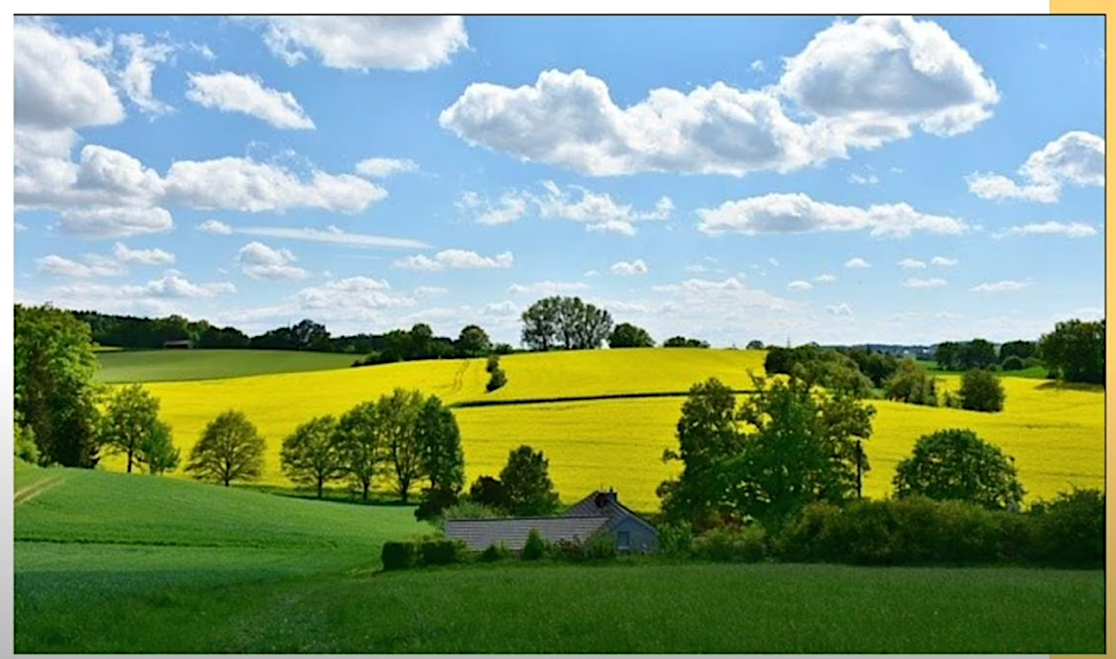

I can see the opened scence with yellow and green grass, also some small trees.

The sky is almost clear with some white clouds flying. The cloulds are exciting with many imagable shapes.

In this photo, a quaint house is tucked into a lush field. Even though the fields consist mostly of grass, trees and shrubs are scattered around. It is likely a summer day with light clouds dotting a clear blue sky.

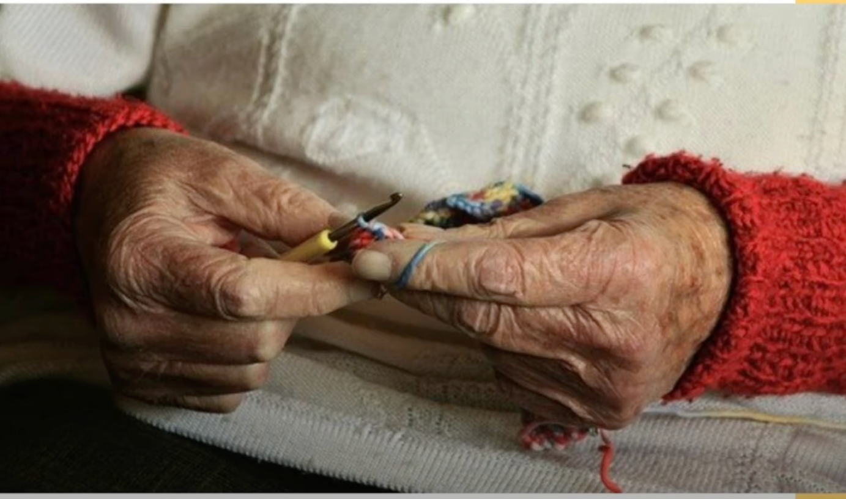

In this photo, it is seem to be that a old woman is sewing somethings. She weared a white shirt with red color on the hands. She may making a small bag. The bag will be colorful. Her hands are yellow and show the sign of time.

This photo shows an elderly person crocheting multicolored yarn. The person is wearing a thick white and red sweatshirt. As she has just started her project, it is unclear what exactly it is she is creating.

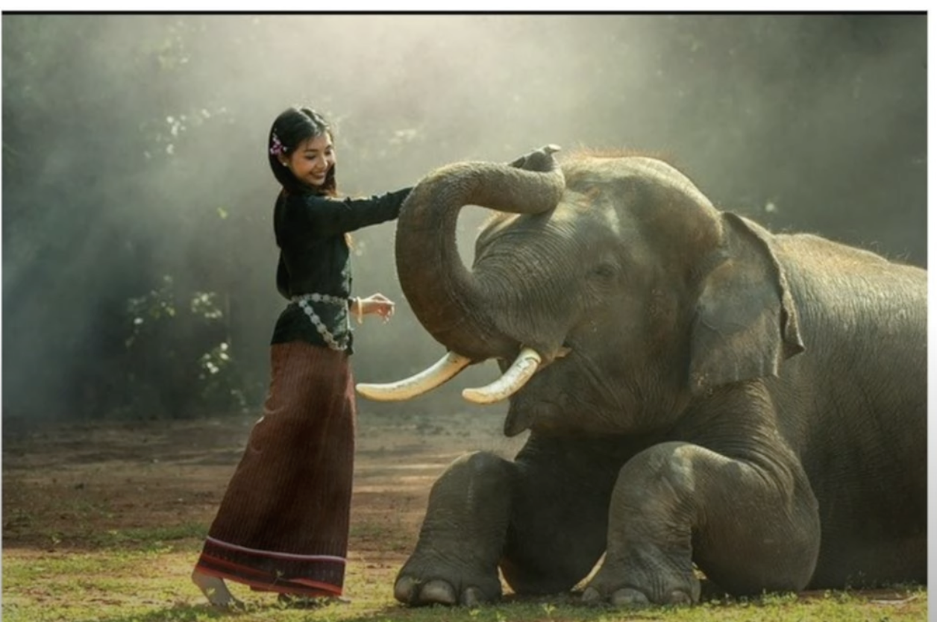

I can see a magical scence on the above photo. A young girl is touching on the nose of black elephant with happy smile. She is wearing a black unique form with brown skirt that belongs to her village. A light is shining all that makes the luxury picture.

The image shows a young girl playing with an elephant. Both the girl and the elephant look relaxed **suggesting** they are familiar with each other. The girl’s hair is black with a purple flower tucked behind **her ear**.

**LiTy**

You can never be too careful ~~in~~ when driving.

**ReCo**

Meditation is a powerful self-improvement tool. Practicing meditation helps to cultivate mindfulness, promoting mental clarity and reducing stress. It can enhance our concentration skills and improvement emotional health. Meditation also fosters self-awareness, allowing us to better understand our emotion**s** and thought patt**erns**. By practicing regular meditation, we can achive a more balanced and tranquil state of mind.

**ReSe**

Modest Temperature document simplify export element structure consistent underestimate

**ReCo**

Practicing spoken English is crucial for improvement. Speaking English in ever**yday** situations helps increase fluency and confidence. One c**an** practice speaking English with friends at work, or even use language exchange platforms. Engaging in English conver**sa**tions helps to apply the vocabulary and grammar rules learned, making the laguage second nature.

**ReAl**

We had no advanced warning that this was going to happen.

**ReSe**

~~Afflusion transquilate~~ Enhance ~~hibrance~~ orientation proximity professional predict